NAME: | PARVENDHAN C
ROLL NO: | 2418011197
DEPARTMENT: | AI&DS

- Find the highest, lowest, sum, and average salary of all employees. Label the columns
Maximum, Minimum, Sum, and Average, respectively. Round your results to the nearest whole number
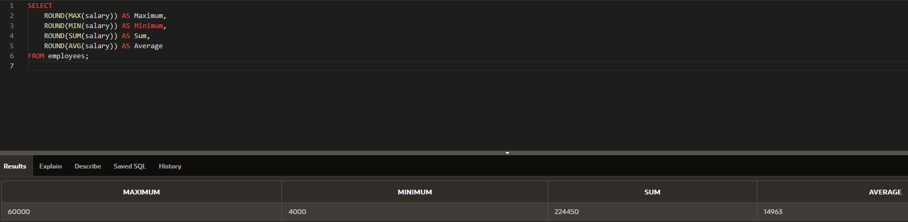
- Modify the above query to display the minimum, maximum, sum, and average salary for each job type.
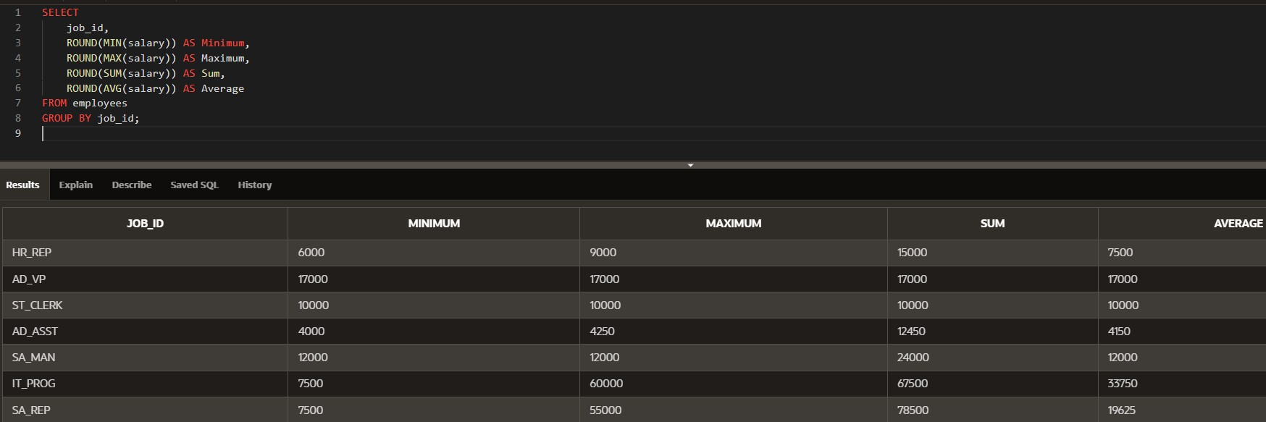
6.Write a query to display the number of people with the same job. Generalize the query so that the user in the HR department is prompted for a job title.
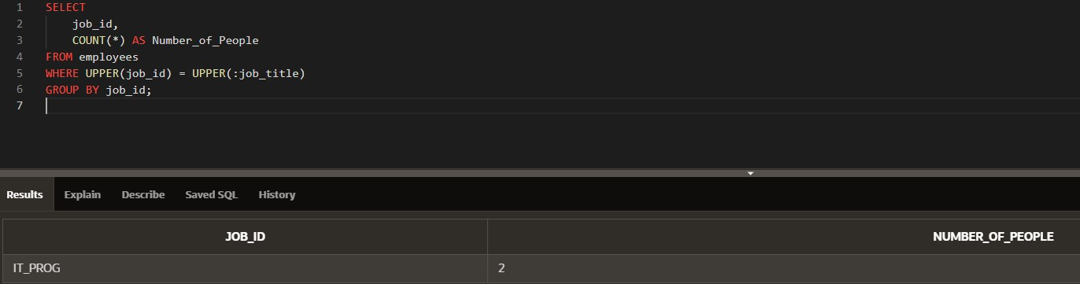
- Determine the number of managers without listing them. Label the column Number of Managers. Hint: Use the MANAGER_ID column to determine the number of managers.
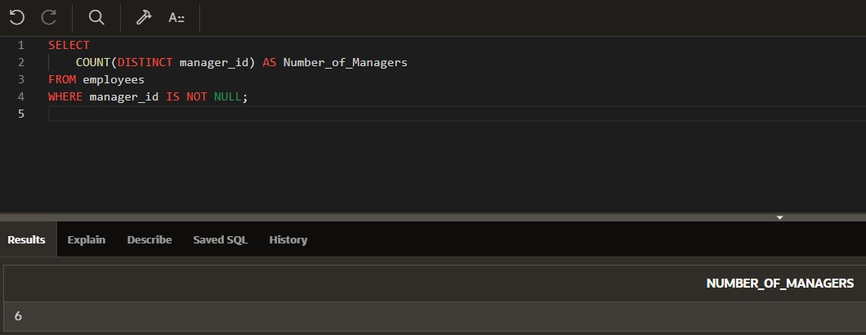
- Find the difference between the highest and lowest salaries. Label the column DIFFERENCE.
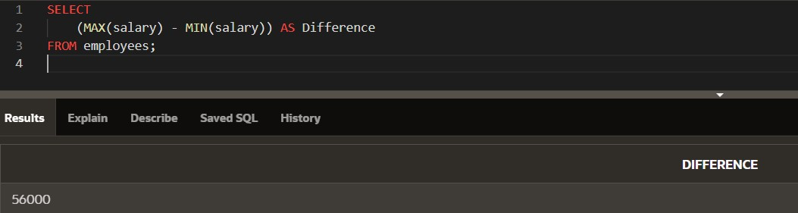
- Create a report to display the manager number and the salary of the lowest-paid employee for that manager. Exclude anyone whose manager is not known. Exclude any groups where the minimum salary is $6,000 or less. Sort the output in descending order of salary.
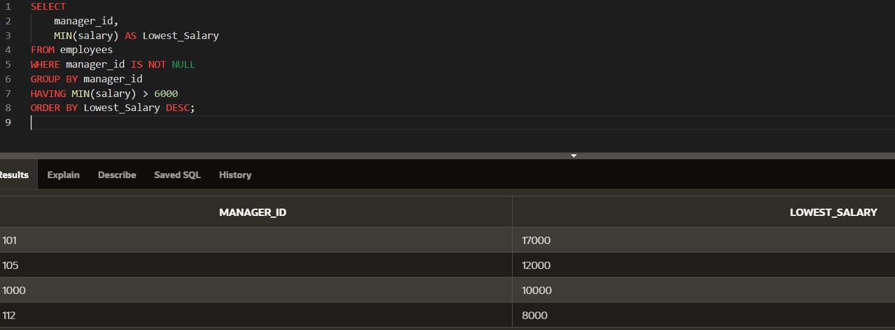
- Create a query to display the total number of employees and, of that total, the number of employees hired in 1995, 1996, 1997, and 1998. Create appropriate column headings.
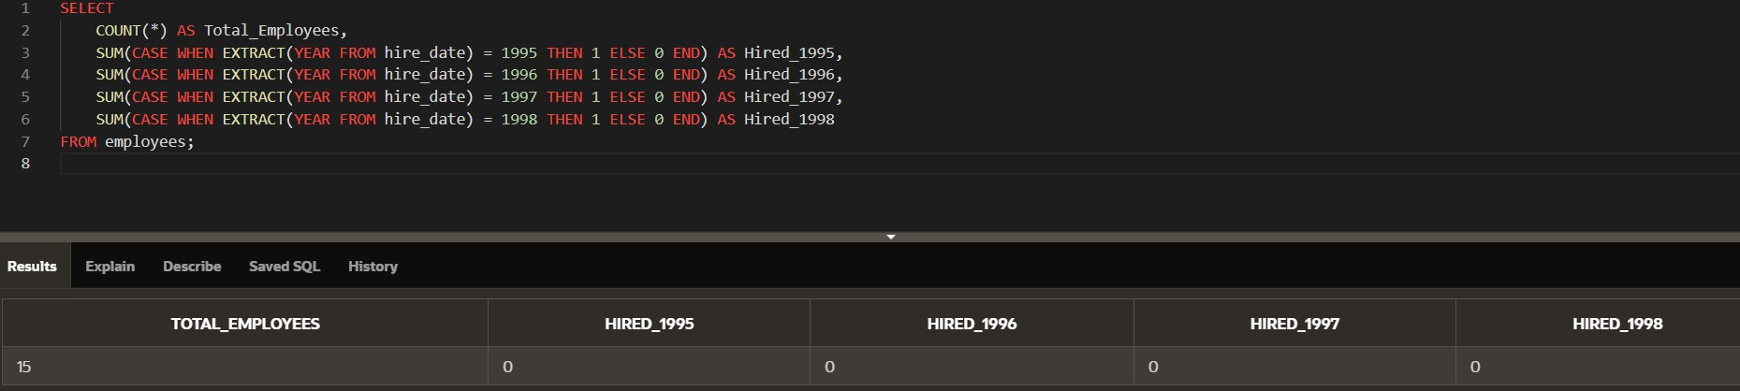
- Create a matrix query to display the job, the salary for that job based on department number, and the total salary for that job, for departments 20, 50, 80, and 90, giving each column an appropriate heading.
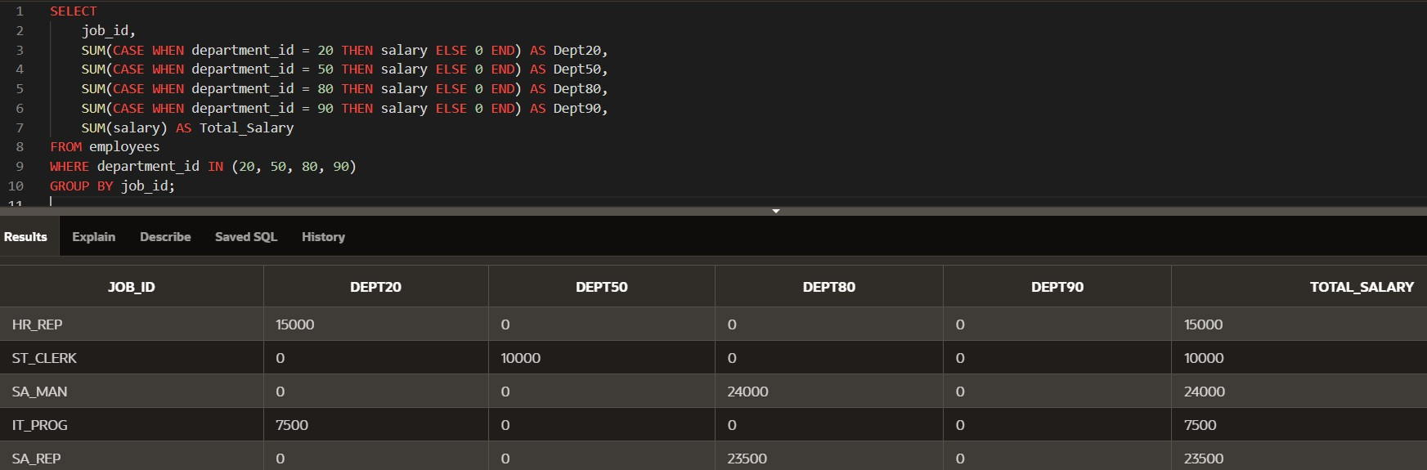
12.Write a query to display each department’s name, location, number of employees, and the average salary for all the employees in that department. Label the column name-Location, Number of people, and salary respectively. Round the average salary to two decimal places. i need sql code for these questions
